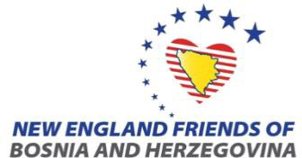
New England Friends of Bosnia and Herzegovina Presents: 7th Annual “A Taste of Bosnia & Herzegovina” Festival

Sunday, October 2nd, 2022| 12:00-6:00 PM

Vendor Application: You must complete this entire form for your application to be processed. (Deadline September 25th, 2022.)
Business Name: Contact Name: Street Address: City, State, ZIP: Telephone: Email Address: Website (if applicable):
Set Up
- Vendor set up is from 8AM – 12 PM. Vendors may not enter the area until 8 AM.
Breakdown
- Vendors must stop selling at 6 PM.
- Vendor vehicles will be allowed to enter the site after 6PM, but blocks must be cleared by 9 PM.
Additional Vendor Rules
- Products must be confined to designated block.
- Vendors provide their own tables, tents, chairs and cleanup.
Please provide a description of product at the event:

VENDORS*
Vendor Categories | Block Sizes and Fees | No. of Spaces | Total Due
NEFBiH Member | (1) 10’Dx10’W | $100
 | (2) 10’Dx10’W | $175
Non-Member | (1) 10’Dx10’W | $150
 | (2) 10’Dx10’W | $250
*Food vendors must submit a license from the City of Cambridge prior to the day of the event

Vendor Signature Date

TOTAL ENCLOSED:
Mail application and fee by September 25th, 2022
To: New England Friends of Bosnia and Herzegovina 2400 Massachusetts Avenue, Cambridge, MA 02140

